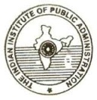
Indian Institute of Public Administration
Bihar Regional Branch
Shiva Path, New Purendrapur, Patna - 800 001
website: <www.iipabiharbranch.org> e-mail: <iipabihar@gmail.com>

Proceedings of the Talk on
Gandhi and Good Governance: Context of 21st Century
A Talk on "Gandhi and Good Governance: Context of 21st Century" was organised by IIPA Bihar Regional Branch, Patna on 31st January, 2018. The Talk was presided over by the Chairman of the Branch Er J K Singh. Prof. R B P Singh, Vice Chancellor, Patna University, Patna was the Chief Guest and Sri A V Sinha, IAS (retd) delivered the main speech.
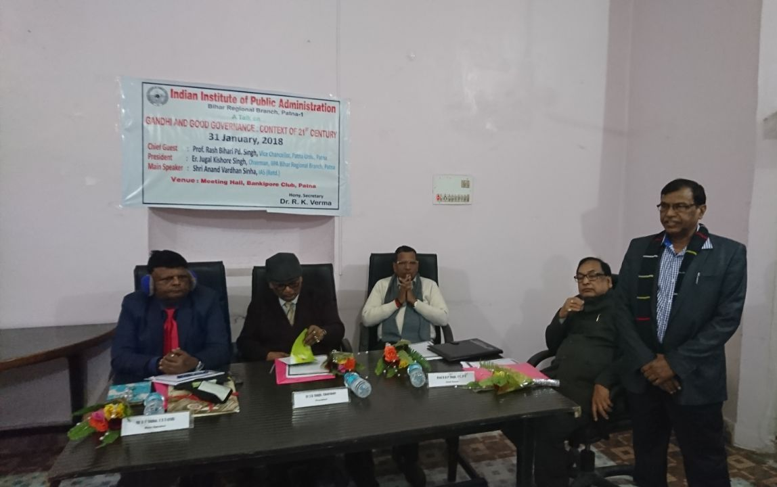
Welcome Address
Dr R K Verma, Hony Secretary of the Branch, in his welcome address, said that in view of arguments against relevance of Gandhi's ideas in 21st Century which has witnessed changes owing to globalisation, IT revolution and new areas of policy priorities, it became an urgent imperative to create a forum of discussion on the relevance of Gandhi's ideas in context of good governance in present times on a day after the occasion of Gandhi's martyr's day. He said that Gandhi's core idea of governance was decentralisation of power, real application of which is the need of the hour. He advocated that Gandhi's ideas should be taken in its spirit not in letters.
In his main speech Sri A V Sinha, narrating Gandhi's experiments of satyagrah right from South Africa to India, said that Gandhi's simplicity, truth and non-violence are the fundamentals of his ideas. Sri Sinha, on the basis of his experience of four decades of administrative service, advocated that practicing Gandhi's ideas in governance can make it good governance. He further posited that country can prosper only by realising Gandhi's ideals.
In his Chief Guest Address, Prof R B P Singh said that the greatest visionary Mahatma Gandhi's every word was like 'mantra' and Gandhi wished the rulers to be true public servants which is the essence of Good Governance. He further referred that though the present problems like corruption, regionalism, social disharmony were not so acute in his times, yet he suggested people to be self-restrained against these problems. He lamented that in this age of women empowerment social accidents like Nirbhaya Kand are taking place. Such accidents are caused by the fact that people have forgotten Gandhi and his teachings. His ideas on cleanliness, sustaining environment, non-violence, truth and skillful education have enlightened the entire world. He advocated that if we follow his ideals, India would be the most socially, economically and politically prosperous and powerful country in the world.
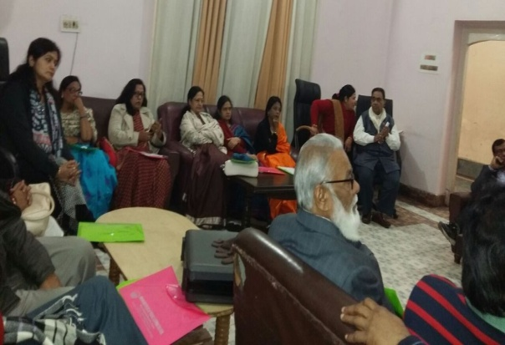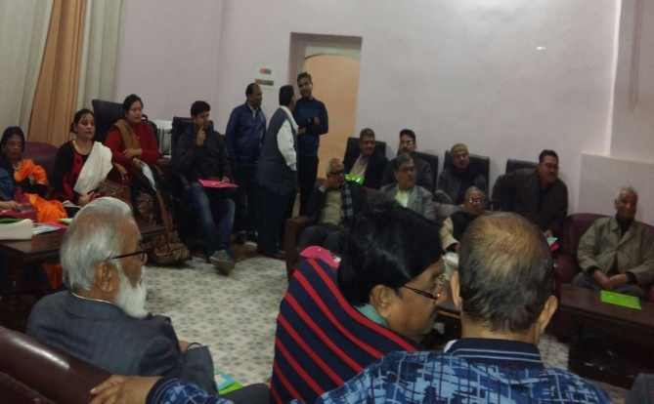
Participants of the Talk
Dr T Prasad former Director, Water Resource Studies Programme, NIT P said that governance system of India carried British legacy which requires thorough change in the light of Gandhi's ideas. He suggested that for true good governance, we need more participative governing institutions at the lower levels. Others who spoke on the occasion were Dr Archana Kumari, Treasurer and Dr Rajesh Kumar, Joint Secretary of the Branch, Dr Henna Tabassum of A N College, Patna, Dr Shashi Bhushan Kumar of L N College, Bhagwanpur, Dr K H Siddiqui and Dr P K Yadav of R N College, Hajipur (Vaishali), Dr S N Tiwary and Dr P K Sinha of Patna University, Sri Abdul Hamid, Deputy Secretary (retd) and Dr Baidyanath Singh, Principal, S R P College, Patna City.
Finally, Dr Sangeeta Vishwanath, Senior Assistant Professor, Government Women's College, Gulzarbagh, Patna proposed the vote of thanks.

